ACTIVATE Health GROUP Exercise Physiology
All classes are supervised by Experienced Accredited Exercise Physiologist’s that tailor the class and exercises to individual needs & abilities. A private initial assessment is preferably conducted prior to joining, at the cost of a regular consultation to ensure participant safety, appropriate group level & class specificity.

Activate LADIES (Ladies only): Group exercises focused for health issues affecting senior females such as Osteoporosis prevention/management, back pain, increased energy, Joint pain and restriction, increased balance and mobility, decrease weight and T2Diabetes prevention.
Activate BLOKES (Men only): Men’s group exercise class targeting specific needs and injures, such as T2 Diabetes, weight loss, Osteoarthritis, and increased quality of life. Class also incorporates elements of increased sports performance such as golf and tennis
Activate MOBILITY (Mixed gender): gentle exercise class for those with restricted mobility, a combination of seated, standing and balance exercises designed to increase mobility and function for life.
Activate NEURO (Mixed gender): A specific group exercise class that is targeted towards those effected by Parkinson’s Disease and its symptoms. With a focus on BIG movements, improving balance & co-ordination and strength in a fun and positive environment.
HYDROTHERAPY (Mixed gender): Offers a fun non-weight bearing form of physical activity focused on improving blood circulation, reducing muscle spasms & joint pain. Helps manage weight, increase overall strength & fitness

Classes Start: 18/January/2018 Private Health item Number: 502
 | MONDAY | TUESDAY | WEDNESDAY | THURSDAY | FRIDAY
8:00 | ACTIV Blokes |  |  |  | $12 Group Exercise Physiology
9:00 | ACTIV Ladies |  | ACTIV Ladies | ACTIV Blokes | $12 Group Exercise Physiology
10:00 | ACTIV Mobility |  |  | ACTIV Mobility | $12 Group Exercise Physiology
11:00 | 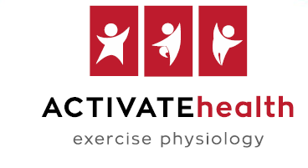 |  |  | ACTIVE Neuro  (Parkinson’s & Stroke)
2:00 |  |  |  |  | HYDRO-THERAPY  Splash-A-Bout  Pool

